13.76: See Problem 12.84; using as the variable instead of 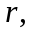
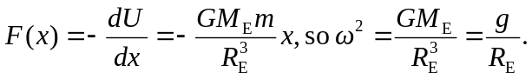
The period is then
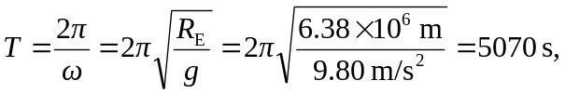
or 84.5 min.

